CELT Home Learning - Suggested Activities for children in Year 1
Weeks Beginning – Monday 15th June and Monday 22nd June 2020
Please find below activities, which may be beneficial to your child’s home learning. We have tried to include a range of practical activities, written activities and activities using technology to cover whatever home setup you may have available. It is not essential you complete all these activities. We know many parents are working and therefore we do not want to ask more of you than you can easily give. Therefore the activities have been arranged into three categories: essential, recommended and additional optional activities. We recommend completing the essential activities then seeing what time is available to commit to additional activities. Please feel free to message your child’s class teacher with questions you have regarding these activities. If you have a concern or need help accessing any of the home learning documents, please do not hesitate to contact us. Teachers would love to see photos or receive information about what you have been up to at home when you have time. Please encourage your child to continue sharing their learning online where possible.
ESSENTIAL daily activities for children in KS1
Online Learning  Phonics and Spelling (15mins): Year 1 children should practise at least 1 sound a day, as well as recapping any sounds from the previous few days.  RWI Lessons http://www.youtube.com/channel/UCo7fbLgY2oA_cFCIg9GdxtQ Daily sounds on Eschools page Top Marks https://www.topmarks.co.uk/english-games/5-7-years/letters-and-sounds Teach my Monster to Read https://www.teachyourmonstertoread.com Phonics Play https://new.phonicsplay.co.uk/  You may also like to access the SPaG challenges below. These focus on punctuation, language choices and spelling rules.  Maths Practise (15mins):  There are many wonderful Maths websites with high quality lessons, interactive games and challenges for you to complete.  White Rose Maths http://whiterosemaths.com/homelearning/ Numbots/Times Tables Rockstars https://play.numbots.com Interactive Maths Frames https://www.coolmath4kids.com/manipulatives Top Marks https://www.topmarks.co.uk/ Carol Vodemam-Maths Factor https://www.themathsfactor.com/ Classroom Secrets Kids https://kids.classroomsecrets.co.uk/  Reading (2 x 10mins daily) Ensure these sessions should include a balance of reading to an adult and sharing stories together. It is also really important to read the colour banded books to support your child’s individual development stage.  Oxford Owl www.oxfordowl.co.uk Borrow Box- online library www.summerreadingchallenge.org.uk Details to come on eschools page | Offline Learning  Phonics and Spelling games (15mins): Have a look at your Year 1 spellings attached. Select 5 to focus on each week making sure you know them really well. You can use the spelling games and activities attached to help you.  For an extra challenge, choose one of your words and see how many different sentences can you write that include that word. Don’t forget to have a go at the SPaG challenges in your pack if you can!  Maths (15mins): We have 9 Maths challenges for you to complete. Can you use the most efficient method? Can you explain your thinking? Remember to talk the process aloud and prove your answer. Using real items found at home can help with your calculations and some children have even drawn their own 10 frames to help. Remember that sometimes there is more than one answer and often more than one way to find the solution.  Reading (20mins): Children should read at least twice a day for 10 minutes. These sessions should include a balance of reading to an adult (books that are linked to their phonics knowledge where possible) and sharing stories together. You might like to carry out some of your essential reading in an extreme location. Make it fun and remember to share your extreme reading pictures with us if you can- we would love to see some of these.
RECOMMENDED daily or weekly activities for children in KS1
Online Learning  Handwriting –Use the rhymes and patterns you have learnt to practise writing your letters correctly. The online tool ‘Skywriter’ might help. https://www.ictgames.com/mobilePage/skyWriter/index.html  Share a Story- Snuggle up with a book together and enjoy how your imagination can take you somewhere new. Alternatively, there are many website where you can hear some wonderful texts:  Cbeebies story time website https://www.bbc.co.uk/cbeebies/stories?page=2 are free audible books available at http://stories.audible.com/start-listen BBC bedtime stories read by some famous faces! https://www.bbc.co.uk/iplayer/episodes/b00jdlm2/cbeebies-bedtime-stories authors are reading their books online at: http://islingtongovuk.j2bloggy.com/lteprimary/authors-reading-their-books/  Get Active! - You could choose to join in with the Joe Wickes workout each day from 9am, have a go at some Cosmic Yoga or have fun with Go Noodle!  Indoor football drills and skills: https://www.youtube.com/watch?v=coQdgX1XbEM Kids HIIT Workout: https://www.youtube.com/watch?v=lc1Ag9m7XQo Kidz Bop Dance Along: https://www.youtube.com/watch?v=sHd2s_saYsQ Zumba Dance Routines: https://www.youtube.com/watch?v=kiRpnDeAOlI Cosmic Yoga: https://www.youtube.com/user/CosmicKidsYoga Yoga Animals: https://www.youtube.com/watch?v=X655B4ISakg PE with Joe Wicks https://www.youtube.com/user/thebodycoach1 Joe Wicks Active 8: https://www.youtube.com/watch?v=TUp2_VAHIrI Go Noodle: https://family.gonoodle.com/ 60 Second Challenges https://www.youthsporttrust.org/60-second-physical-activity-challenges | Offline Learning  Time to Talk and Walk (10 mins) – Play ‘Name 5 Things’. Name 5 things that are yellow, begin with S that live in the sea etc. Are there any letters you cannot think of 5 things for?  Handwriting Regularly practise your handwriting using the rhymes and patterns you have learnt to help you form each letter correctly. Remember that your presentation is really important in ensuring other people can read the beauty in your words.  Writing - Draw a story telling path - Draw it with chalk outside/make a long strip of paper/ use some left over wall paper. Draw a path and then draw the events, in order, from your favourite story along the path. Make it bright and colourful. Then walk along the path and retell the same story. Invite someone else to walk along the path and enjoy the story. You might like to make a mini story path and move a toy along the journey.  Story of the Week- The world around us is so special and fragile. We need to look after it and everything it beholds. Can you find, read, retell or write a story based around the world or an animal within it? ‘The Snail and the Whale’ is just one lovely example.  Share a story – Create a home hot seating chair. Pretend to be Goldilocks, the big bad wolf or the Gruffalo. The rest of the family need to ask you questions. Your job is to stay in character while you answer these questions.  Get Active! – Shadow Tag, this is a game for a sunny day. Take it in turns to jump on each other’s’ shadows. It becomes trickier as the sun rises in the sky so it will be fun to play at different times of the day.  Board games – Can you design your own board game? Include challenges in order to roll the dice again and forfeits for landing on some specific squares? Do you need to miss a go or move back a square?

Music
Homemade Musical Instruments
Can you make a shaker, a tambourine, drum or an elastic band guitar? Choose one to make and then create a piece of music using loud and soft sounds, change tempo (fast or slow) and build to a crescendo (biggest loudest point)!
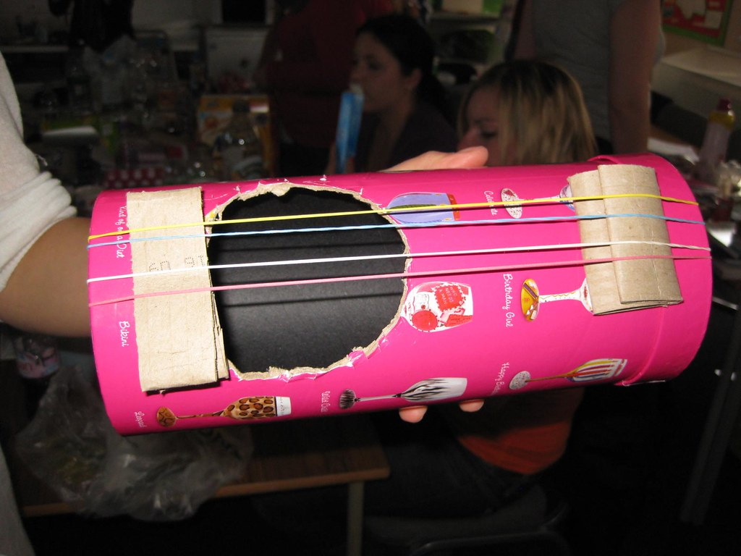

GEOGRAPHY

The 7 Continents continued!

In the last planning unit we began learning about the 7 continents. Here is a song to help you remember them’.
https://www.youtube.com/watch?v=K6DSMZ8b3LE
Choose two more continents to look at closely and to add to the passport you made last time.
Find out some information about them to go into your passport. Is it an island? Is it in the Northern or Southern Hemisphere? Which animals live there? What is it famous for? What is the climate like? Does it have an ocean?

PE
Colossal Catching
Can you use a soft ball (if you have one) or some rolled up socks, balloon or scarf for throwing and catching? Throw and catch your item following the routine below. If you drop your item you have to start from the beginning again. Can you achieve a gold medal?
-5 baby throws
-5 small throws
-5 medium throws
-5 big throws
-5 giant throws
-5 colossal throws

RE/PSHE
Lockdown
Good bits and bad bits. What are you enjoying? What are you missing? Talk about and draw on a poster. What would you like to do when you can get out and about?
Building confidence and self-esteem.
Discuss self-esteem and what high/low self-esteem looks like: What makes you feel good? (How could we make you feel good each day?) What could you do to make you feel good every day?

Year 1
Additional Optional Activities
You may wish to choose to complete one or more of these activities over this two week period.
These have been organised into different subject areas and are based around your child’s year group theme.

COMMUNITY SPIRIT

Make Someone Smile

Send someone you know a joke to cheer them up. You can send it by email or in the post. Remember to include a lovely picture that they can put up in their home.

ART/DT
Patterns
An Amazing Fact! – Did you know bubble wrap was initially invented to be used as wallpaper?
Wallpaper is created from a series of repeated patterns. Have a look around your home or a local DIY store to see if you can spot a repeated pattern wall paper. Have a go at creating your own wallpaper by designing a pattern in the first box and repeating it across the page.
Unique Animal Print
Many animals have patterns in their fur. Can you create an animal pattern clue for someone? Can they guess which animal you were thinking about based on your print clue?

HISTORY

Great Explorers

Our world has been discovered by many famous explorers.
Can you research a famous explorer who discovered something or somewhere in our wonderful world? How has this impacted on our world today and what we know about the world we live in?

SCIENCE

Hungry Animals

-.Animals that eat other animals are called carnivores.
-Animals that eat plants are called herbivores.
-Animals that eat both plants and other animals are called omnivores.
Choose an animal and draw it. Write underneath.

I am a __________ and I like to eat ___________.

Can you create one of these for two other animals?

Find some old magazines, cut out all the animals that you see. Now see if you can sort them into 3 groups- herbivores, carnivores and omnivores.

Phonics Games Spellings
Use these games to support your Phonic knowledge. (Select 5 each week to learn.)
These games and activities do not require children to be online and can be adapted to suit your child’s ability. You can use different sets of sounds and words. Please use the information shared by your class teacher regarding which phonics group and spellings your child should be accessing. |  |  | Spelling Memory Games  ‘Add-A-Letter’ Game  This game is a fun way to learn with a partner. One of you starts writing the spelling word on the paper by writing one letter. The next one adds the next letter. As many words on the list include words that start with the same sounds, it will be a challenge to know which word your partner intended on writing.  Rainbow Words  First write your spelling in pencil. Trace over the word five times using a different coloured pencil each time.  Fancy Letters  Write out each of your spelling words using fancy writing. Your letters could be curly or dotty.  Tell a story  Write a story using all of your spelling words. Make sure you underline all of your spelling words.  Magic painting  Use a paintbrush and water to write the  words on the path outside. | 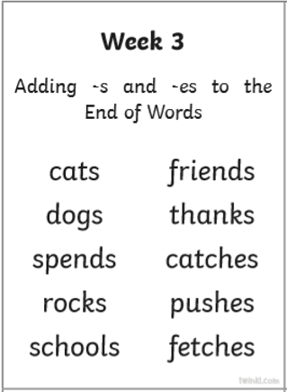 | Numbers  I can spell all the numbers up to 20.  One Two Three Four Five Six Seven Eight Nine Ten Eleven Twelve Thirteen Fourteen Fifteen Sixteen Seventeen Eighteen Nineteen Twenty | More Common Exception Words  about all an and as at back big but called came can children could dad day don’t down for from get got had help her into just little look made make Mr Mrs mum not now off oh old out people saw
Muffin Tin Toss  Set it up:  Write word families (such as –ing) on circle cut-outs. Put them in the 12 spaces of a muffin tin. Place the tin and a container of buttons or counters in a center. Add paper and pencils.  Play it:  Take turns tossing a button or counter into the tin. Think of a word that uses the word family written in the tin where the button lands, and then write the word.  For example,  if the button lands in the tin with the –ing cut out, you might write jumping. Play several times.  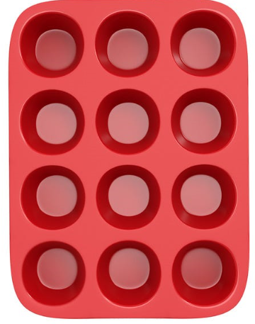 | Kaboom!  Using craft sticks or strips of card and a cup, each player should pull a stick out of the cup and say the sound written on the stick they draw. If they say it correctly they get to keep that stick. However, “KABOOM” is written on one stick and every time it’s pulled out, the unlucky player has to put all their sticks back in the cup. You can even set a timer for a fun speed-round version. | Tic Tac Toe  Make a grid and add the sounds you are learning. Read and cross off the sounds to block your partner from scoring three in a row.  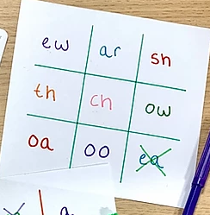
 |  |  |  | 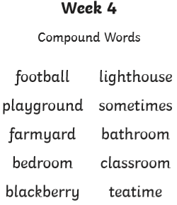
 | Hopscotch  Draw hopscotch markings on the ground (the number of squares and the shape they are arranged is up to you). In each square write some of the sounds you have been learning. Ask someone to call out the sounds and jump on the correct sound as it is called out. You could also play this with your common exception words.  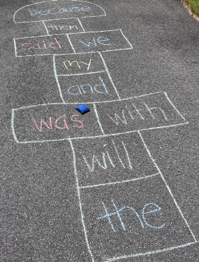 | Word ball  All you need is a ball. First, the adult calls out a sound – ay/igh/ee and the child responds with a word containing that sound – play/night/tree.  Then, the adult throws the ball to the child and the child gives the adult a letter to find a word for, and on and on.  You can make the game even more fun by kicking the ball or chasing each other to tag with the ball.  You can also play rhyming ball, where the thrower provides a word for the catcher to say a matching rhyming word.  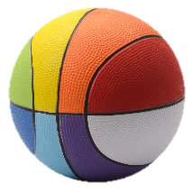
 |  |  |  | Adding pre-fixes and suffixes  I know about some of the most common suffixes to change the tense of a word.  jump > jumping > jumped  I am great.  I am greater.  I am the greatest.  I can add ‘s’ or ‘es’ for plural words.  dog > dogs  box > boxes  I can use the prefix ‘un’ to change the meaning.  ‘I am happy.’ or ‘I am unhappy.’ | Name the Letters of the Alphabet  I can name the letters of the alphabet in the right order.  I can use letter names to distinguish between alternative spellings of the same sound.  a b c d e f g h i j k l m n o p q r s t u v w x y z | Contracted words, are short words made by putting two words together. Letters are omitted in the contraction and replaced by an apostrophe which shows where the letters would be if the words were written in full. it is - it’s’ I am – I’m did not – didn’t cannot – can’t

SPaG Writing Prompts
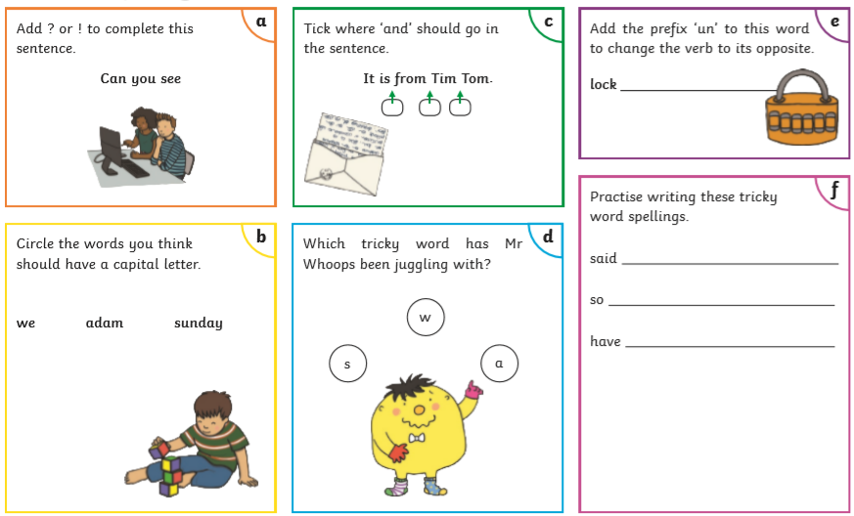 | 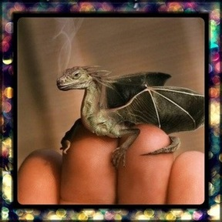  - Where is it from?  - Why is it so small?  - Are there more like him?  - Where does he live?  - How will you look after it?  - Will you keep it a secret or tell someone?  - What is it called?  - Is it magic? What magic can it do? | Story Objects  Choose two objects to include in your story. You will need to think about where the object was found, does it have magic powers and how it will be used to make something amazing happen?  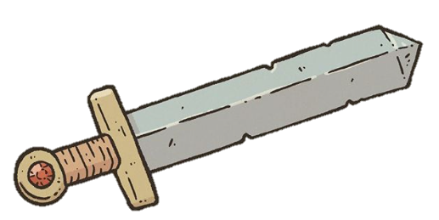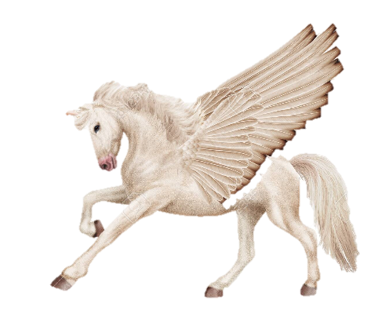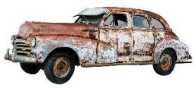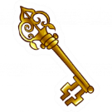
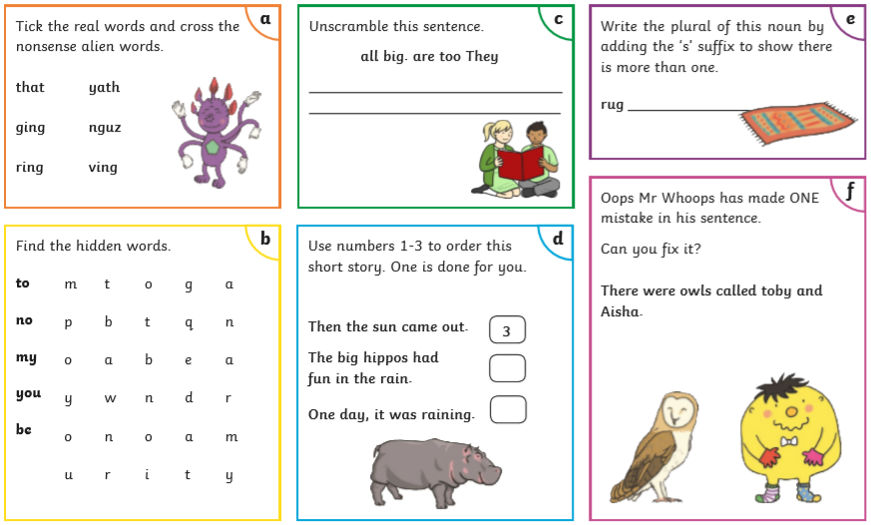 | 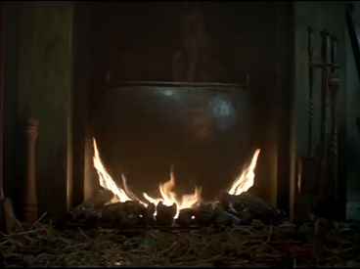  What is this?  What happened here?  Who was involved?  What familiar story is it from? | Where does the staircase lead?  What will we find at the top?  Can you illustrate it?

Maths Challenges
Dappy Dog runs Donaldson Bakery on Rafferty Road. He has some very exciting news.  “We are going to be having a party. We have a special guest attending so we need to work together to get everything ready.”  Their first job is to count the biscuits in the bags.  There are 5 bags of biscuits.  Each bag has 10 biscuits.  How many biscuits are there all together? | In the kitchen the donuts have just come out of the oven. They are on 3 baking trays. They need to be in equal groups.  They need to make the trays equal. How many donuts should be on each tray to make equal groups? | Cheeky Rosie Rabbit could not resist the donuts and sneakily eaten one donut from 2 of the trays. How naughty!  How can you make the donuts equal now?  Complete the sentence to explain how many donuts are on the baking tray now.  There are __ donuts on __ baking trays.  How many donuts are left altogether now?
Benny Bear and Penny Pig are counting up the scones.  Scones are baked in groups of 4 and there are 4 groups of scones.  Benny Bear says that there are 16 scones.  Penny Pig says there are 8 scones.  Who is correct and why?  They have 16 scones but they need 20 scones.  How many more gorups do they need? | Charlie Chicken is setting the party table and he is making a plan. Complete the plan to show how the cupcakes and biscuits will be laid out on the table.  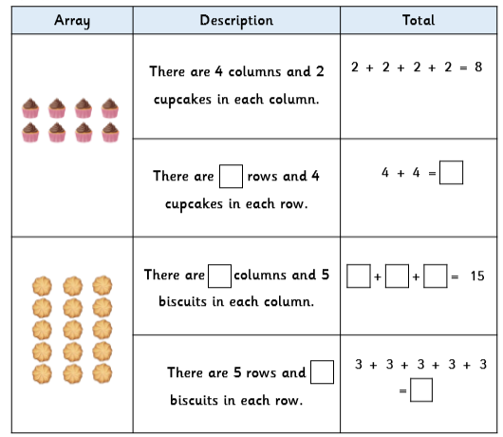 | Oh no! Ralphy has just had news that more guests are coming to the party.  They are going to have to make another cake. This recipe is for 1 cake, the ingredients need to be doubled.  How much of each ingredients do they need?
There are 20 flowers for decorating the party room.  How can the flowers be grouped equally?  There are 5 tables. Will the same amount of flowers fit on each table? Explain how. | There is just one thing left to do and that is to share out the food with everyone at the party.  Luckily, The Good Fairy waves her magic want and the food is shared out equally onto all of their plates.  All 5 animals get 4 biscuits each. How many biscuits did the Good Fairy share out altogether? You can use the plates to help you. | Two cakes are cut into 10 slices each.  It needs to be shared between 16 people. Each person gets one slice. How many slices pf cake are left over?  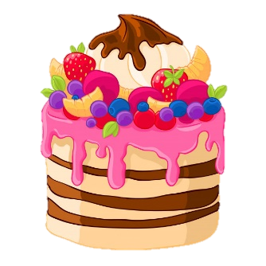
Outdoor Learning Activities Social, Emotional and Mental Health
Hammering a Nail  Give your child your smallest hammer and a piece of soft wood. Pick nails with the widest head. At first you’ll have to start each one for him/her. When your child is ready next push a nail through a small piece of cardboard so it’s held in place as they hammer it into the wood. They can hold the edge of the cardboard instead of the nail (to protect their fingers). Once they’ve mastered that method, have them try holding the nail. | Labelling a Plant  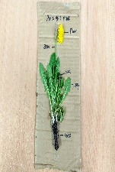  Use a common garden plant such as daisy, dandelion, clover, pineapple weed or plantain. Children may carefully take a full plant and stick it to their board.  Emphasise how important flowers are as a food source for pollinating insects. Look closely at the flower can the children extract some pollen on a cotton bud? | Barefoot Safari  Identify a short route. Incorporate a series of different surfaces such as: bark mulch; rounded gravel, fir cones; sand; pebbles; long grass; leaf litter and not forgetting some mud!  Going barefoot is a great health and wellbeing activity encouraging children to relax, improve their physical awareness and be more mindful of the sensations that they are experiencing in the moment.  . | Buddhism Outdoors  At the heart of the Buddhist faith is the ability to meditate and appreciate the moment (mindfulness.) Labyrinths help focus the mind. A labyrinth is a winding pattern with a single pathway leading to the centre and back out the same way. There are no trick pathways or dead ends. It could be created from natural materials such as rocks, leaves, moss, sticks, sand or gravel.
Birdy Survey  Look for birds as you take a walk, or as you sit and watch out of the window. It can be done on a single day, or over a longer period of time You will need to be patient and quiet. Decide how long you will watch for. Record the total number of birds of each different type using a tally chart. 4 common birds to look out for are, robin, magpie pigeon annd great tit. You can always add more. | Natural Number Poem  Look around and gather 5 natural objects. Write out their lines in numerical order as a poem – either on paper or chalked onto the playground.  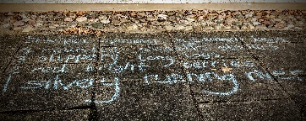  Lay out each phrase as: Number – Adjective – Alliteration – Noun e.g.  “Three green, spiky, conker-cases.” | The Five Senses Workout  Notice 5 things that you can see. Notice 4 things that you can feel. Notice 3 things you can hear. Notice 2 things you can smell. Notice 1 thing you can taste.  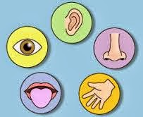 | Breathing Buddies  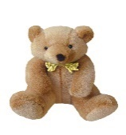  Grab your favourite teddy or stuffed toy. Lay on your back with your buddy on your belly. Now focus your attention on the rise and fall of the stuffed toy/animal as you breathe in and out.
Tremendous Trees  Find, observe and accurately draw a tree close to your house. This will test your observational drawing skills! To draw a tree accurately you will need to look at size, colour and texture.  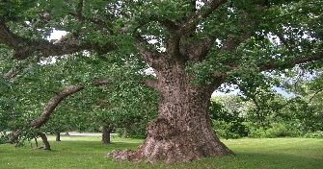 | Ball Run Challenge  To design and build a tennis ball run. The tennis ball run must be on at least two levels and at different heights. It must change direction and involve at least one right angle. It must have a start and finish point. The tennis ball must be able to travel from beginning to end on its own. The scale of your ball run is up to you! | Thankfulness  This helps children to appreciate the abundance in their lives, as opposed to focusing on all the toys and goodies they crave. It can be done at dinner time when everyone shares one thing they are thankful for. | Lavender Playdough  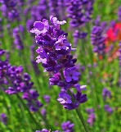  We all know the subtle power of lavender to induce calmness and sleepiness. Why not add some to your Playdough? Pushing, squeezing and modelling with playdough is a great stress reliever. Ask the children to take out their squabbles on the dough!
Happy Stones  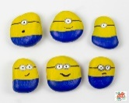  Can you decorate a pebble or stone and then hide it for someone else to find.  This Photo by Unknown Author is licensed under CC BY-NC-ND | 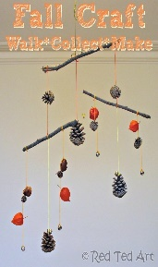  Natural Mobile  Use natural materials from your garden or from your walk to create a natural mobile. | Reading Nook  A low effort way to encourage children to relax and unwind is to throw together a reading nook with sheets and blankets. Toss in some cushions, blankets and basket of books and they can lie down to browse through them and rest their bodies. | Take a Colouring Break  This can be a great mindfulness activity that reduces anxiety. Make a trip with your child to pick up some crayons and markers and get them excited about filling in the pages of a colouring book.

