No-pastry mini mushroom quiches recipe
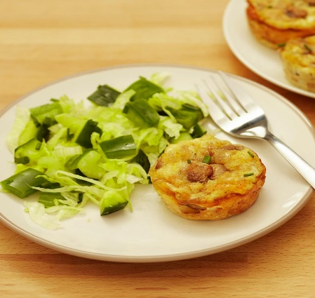
Light mini quiches without the pastry, served with a crunchy green salad.
Prep time
20 mins
Cooking time
15 mins
Effort
Medium effort
Serves
4

Ingredients
- 1 tsp lower-fat spread to grease tin
- 1 tbsp vegetable oil
- 100g button mushrooms, cut into quarters
- 1 small onion, finely chopped
- 2 eggs, beaten
- 50ml semi-skimmed milk
- Large pinch of black pepper
- Large pinch of nutmeg
- 10g reduced-fat cheddar, finely grated

- To serve:
- ¼ iceberg lettuce, shredded
- ½ green pepper, diced
- 1 celery stick, sliced
- ¼ cucumber, chopped
- A few stems of fresh chives, chopped

Method
Grease the bottom and sides of 4 holes of a muffin tray. Cut 4 circles of baking paper and place in the bottom of each hole.

Heat the oil in a small frying pan, add the onions and cook for a couple of minutes until softened, then add the mushrooms and cook for a further few minutes. Transfer to the muffin tray.
Experiment with different vegetables – using 160g of thawed frozen vegetables instead of the mushrooms and onion saves time as there's no need to pre-cook them.
Mix the eggs with the milk, black pepper and nutmeg. Pour into the muffin tray and sprinkle on the cheese.

Bake in a preheated oven (180C/160C fan/gas mark 4) for 15 minutes until risen and brown.

Leave in the tin to cool for 10 minutes. Remove by running a knife around the edge of the tin and then serve with the green salad.
Try them hot with some grilled tomatoes and toast for a delicious weekend brunch. These are also a good packed lunch option – just add some crusty bread.

